W2D1 Homework

1. )

* Collection – it is the root interface of Java Collections Framework
* Collections –  utility method class for doing certain operations. It provides useful operations for handling the collections.
* List – this is where the elements are collected and stored. It has a size which counts the number of elements that have been added. Elements can be added here either to front, back or middle. It handles the elements added, their order and indexes and the total size. Elements here can be duplicated.
* Set – elements here are unique and cannot be duplicated
* Map –it is an unordered collection that uses keys and values in mapping

Difference between ArrayList and LinkedList

* ArrayList – In ArrayList, the size of the array is fixed. If we want to insert or delete a value to a list, the elements after where the value will be placed must be moved.
* LinkedList – In LinkedList, the size is dynamic, and unlike in Array, it is easy to insert and delete in LinkedList. When deleting an element in LinkedList, the link will point to the next element after the element that was deleted. Also, Random access is not allowed here and we have to access elements sequentially starting from the first node.

Difference between HashMap and TreeMap

* HashMap – In HashMap, the order of the keys can be sorted but there’s no assurance that the order will retain
* TreeMap – In TreeMap, the order of the keys can be sorted and will definitely be in order

2. )

1. Output:

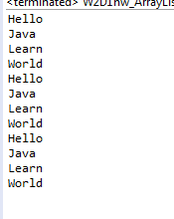

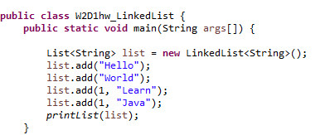

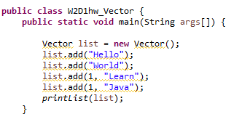

Difference between ArrayList and Vector:

* ArrayList is non-sychronized that means multiple threads can work on ArrayList at the same time while Vector is synchronized, only one thread can perform an operation at a time.

3.)

Output:

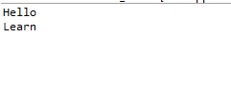

4.) Compile and run well, and output 3